**DBMS COMPLETE UNIT - 3**

**For better understanding watch this youtube playlist along with the topics covered in this written material--**

<https://youtube.com/playlist?list=PLxCzCOWd7aiFAN6I8CuViBuCdJgiOkT2Y>

# Storage System in DBMS

A database system provides an ultimate view of the stored data. However, data in the form of bits, bytes get stored in different storage devices.

In this section, we will take an overview of various types of storage devices that are used for accessing and storing data.

## Types of Data Storage

For storing the data, there are different types of storage options available. These storage types differ from one another as per the speed and accessibility. There are the following types of storage devices used for storing the data:

* Primary Storage
* Secondary Storage
* Tertiary Storage

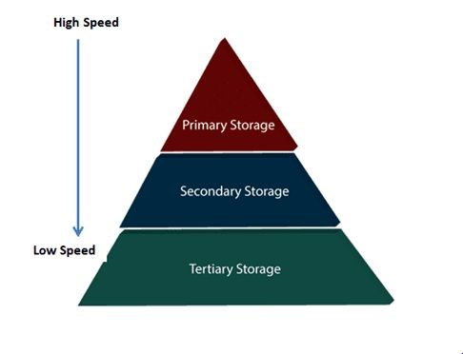

## Primary Storage

It is the primary area that offers quick access to the stored data. We also know the primary storage as volatile storage. It is because this type of memory does not permanently store the data. As soon as the system leads to a power cut or a crash, the data also get lost. Main memory and cache are the types of primary storage.

● **Main Memory:** It is the one that is responsible for operating the data that is​ available by the storage medium. The main memory handles each instruction of a computer machine. This type of memory can store gigabytes of data on a system but is small enough to carry the entire database. At last, the main memory loses the whole content if the system shuts down because of power failure or other reasons.

1. **Cache:** It is one of the costly storage media. On the other hand, it is the​ fastest one. A cache is a tiny storage media which is maintained by the computer hardware usually. While designing the algorithms and query processors for the data structures, the designers keep concern on the cache effects.

## Secondary Storage

Secondary storage is also called as Online storage. It is the storage area that allows the user to save and store data permanently. This type of memory does not lose the data due to any power failure or system crash. That's why we also call it non-volatile storage.

There are some commonly described secondary storage media which are available in almost every type of computer system:

* **Flash Memory:** A flash memory stores data in USB (Universal Serial Bus)​ keys which are further plugged into the USB slots of a computer system. These USB keys help transfer data to a computer system, but it varies in size limits. Unlike the main memory, it is possible to get back the stored data which may be lost due to a power cut or other reasons. This type of memory storage is most commonly used in the server systems for caching the

frequently used data. This leads the systems towards high performance and is capable of storing large amounts of databases than the main memory.

* **Magnetic Disk Storage:** This type of storage media is also known as online​ storage media. A magnetic disk is used for storing the data for a long time. It is capable of storing an entire database. It is the responsibility of the computer system to make availability of the data from a disk to the main memory for further accessing. Also, if the system performs any operation over the data, the modified data should be written back to the disk. The tremendous capability of a magnetic disk is that it does not affect the data due to a system crash or failure, but a disk failure can easily ruin as well as destroy the stored data.

**Tertiary Storage**

It is the storage type that is external from the computer system. It has the slowest speed. But it is capable of storing a large amount of data. It is also known as Offline storage. Tertiary storage is generally used for data backup. There are following tertiary storage devices available:

* **Optical Storage:** An optical storage can store megabytes or gigabytes of​ data. A Compact Disk (CD) can store 700 megabytes of data with a playtime of around 80 minutes. On the other hand, a Digital Video Disk or a DVD can store 4.7 or 8.5 gigabytes of data on each side of the disk.
* **Tape Storage:** It is the cheapest storage medium than disks. Generally,​ tapes are used for archiving or backing up the data. It provides slow access to data as it accesses data sequentially from the start. Thus, tape storage is also known as sequential-access storage. Disk storage is known as direct-access storage as we can directly access the data from any location on disk.

# Storage Hierarchy

Besides the above, various other storage devices reside in the computer system. These storage media are organized on the basis of data accessing speed, cost per unit of data to buy the medium, and by medium's reliability. Thus, we can create a hierarchy of storage media on the basis of its cost and speed.

Thus, on arranging the above-described storage media in a hierarchy according to its speed and cost, we conclude the below-described image:

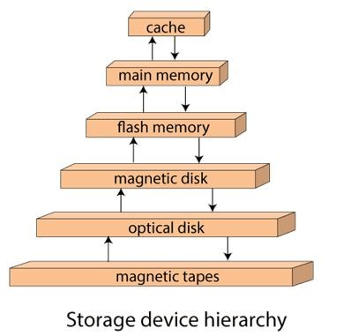

In the image, the higher levels are expensive but fast. On moving down, the cost per bit is decreasing, and the access time is increasing. Also, the storage media from the main memory to up represents the volatile nature, and below the main memory, all are non-volatile devices.

# Indexing in DBMS

* Indexing is used to optimize the performance of a database by minimizing the number of disk accesses required when a query is processed.
* The index is a type of data structure. It is used to locate and access the data in a database table quickly.

**Index structure:**

Indexes can be created using some database columns.

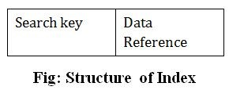

* The first column of the database is the search key that contains a copy of the primary key or candidate key of the table. The values of the primary key are stored in sorted order so that the corresponding data can be accessed easily.
* The second column of the database is the data reference. It contains a set of pointers holding the address of the disk block where the value of the particular key can be found.

## Indexing Methods

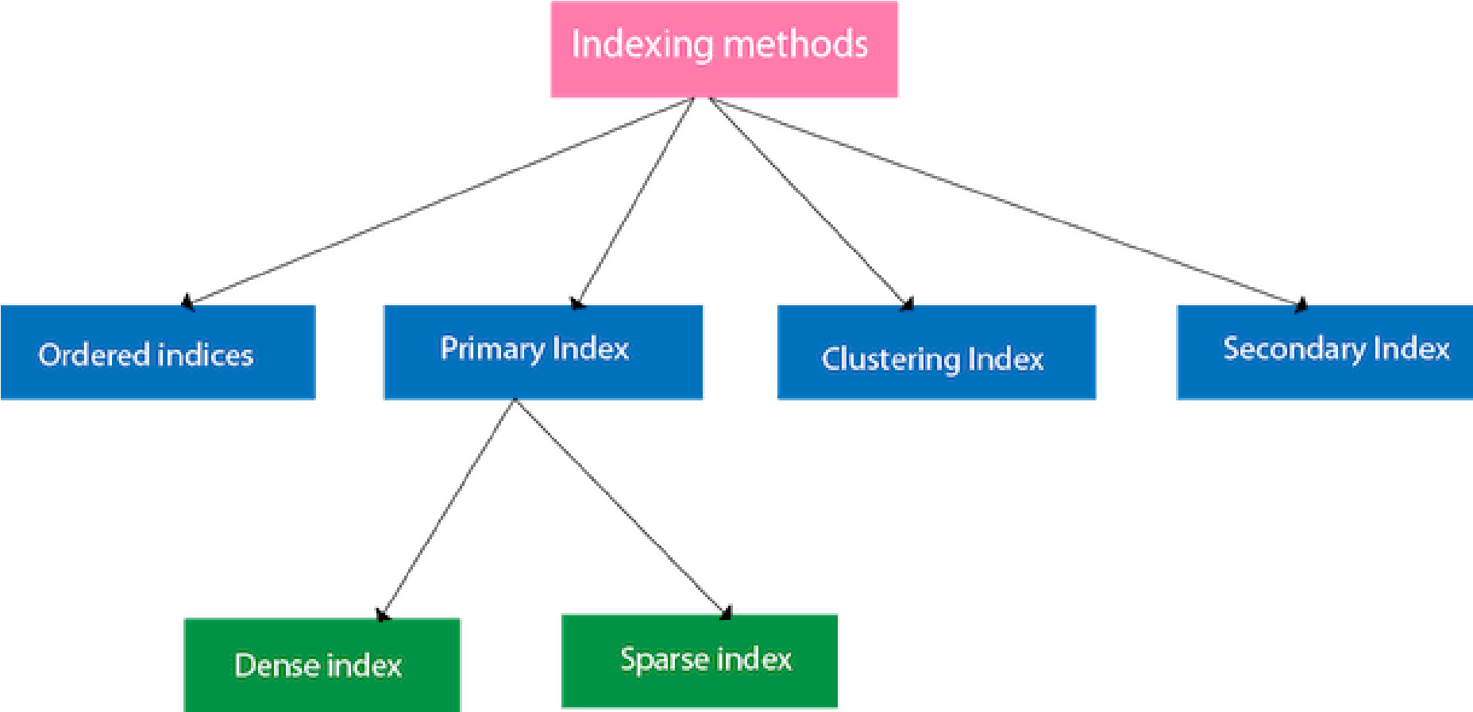

## Ordered indices

The indices are usually sorted to make searching faster. The indices which are sorted are known as ordered indices.

**Example**:​ Suppose we have an employee table with thousands of records and each of which is 10 bytes long. If their IDs start with 1, 2, 3....and so on and we have to search students with ID-543.

* In the case of a database with no index, we have to search the disk block from starting till it reaches 543. The DBMS will read the record after reading 543*10=5430 bytes.
* In the case of an index, we will search using indexes and the DBMS will read the record after reading 542*2= 1084 bytes which are very less compared to the previous case.

## Primary Index

If the index is created on the basis of the primary key of the table, then it is known as primary indexing. These primary keys are unique to each record and contain 1:1 relation between the records.

As primary keys are stored in sorted order, the performance of the searching operation is quite efficient.

The primary index can be classified into two types: Dense index and Sparse index.

**Dense Index:**

○ For every search key value in the data file, there is an index record.

○ This record contains the search key and also a reference to the first data record with that search key value.

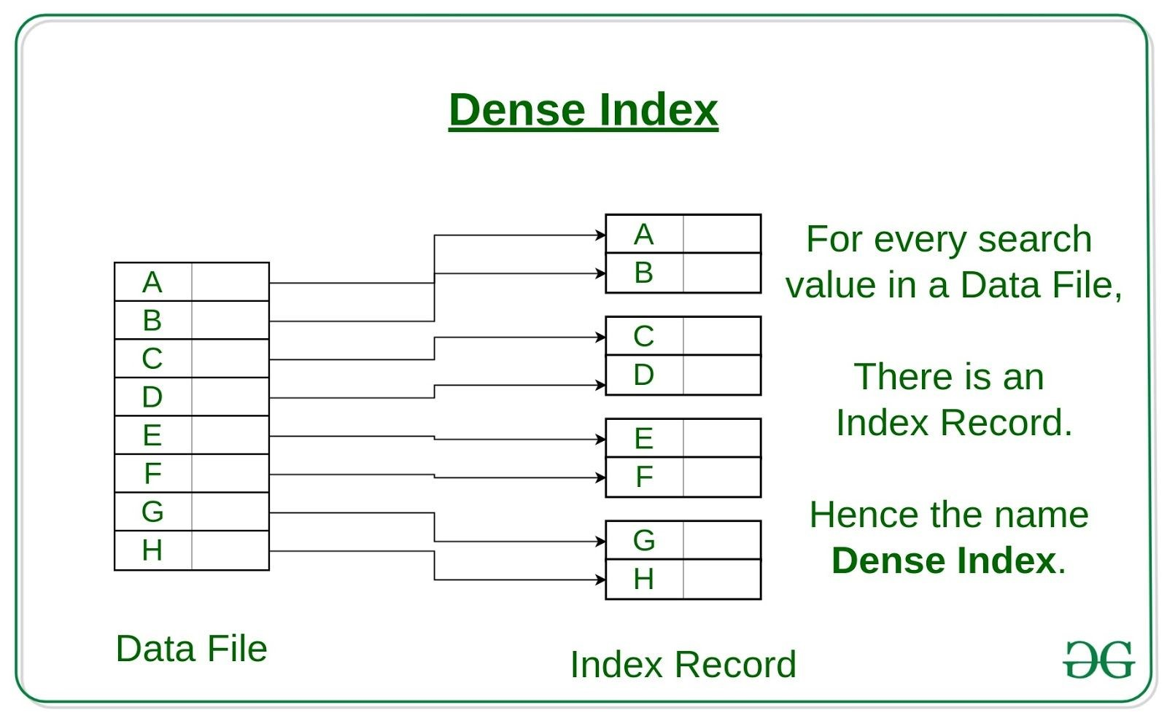

**Sparse Index:**

○ The index record appears only for a few items in the data file.

Each item points to a block as shown.

○ To locate a record, we find the index record with the largest search key value less than or equal to the search key value we are looking for.

○ We start at that record pointed to by the index record, and proceed along with the pointers in the file (that is, sequentially)

until we find the desired record.

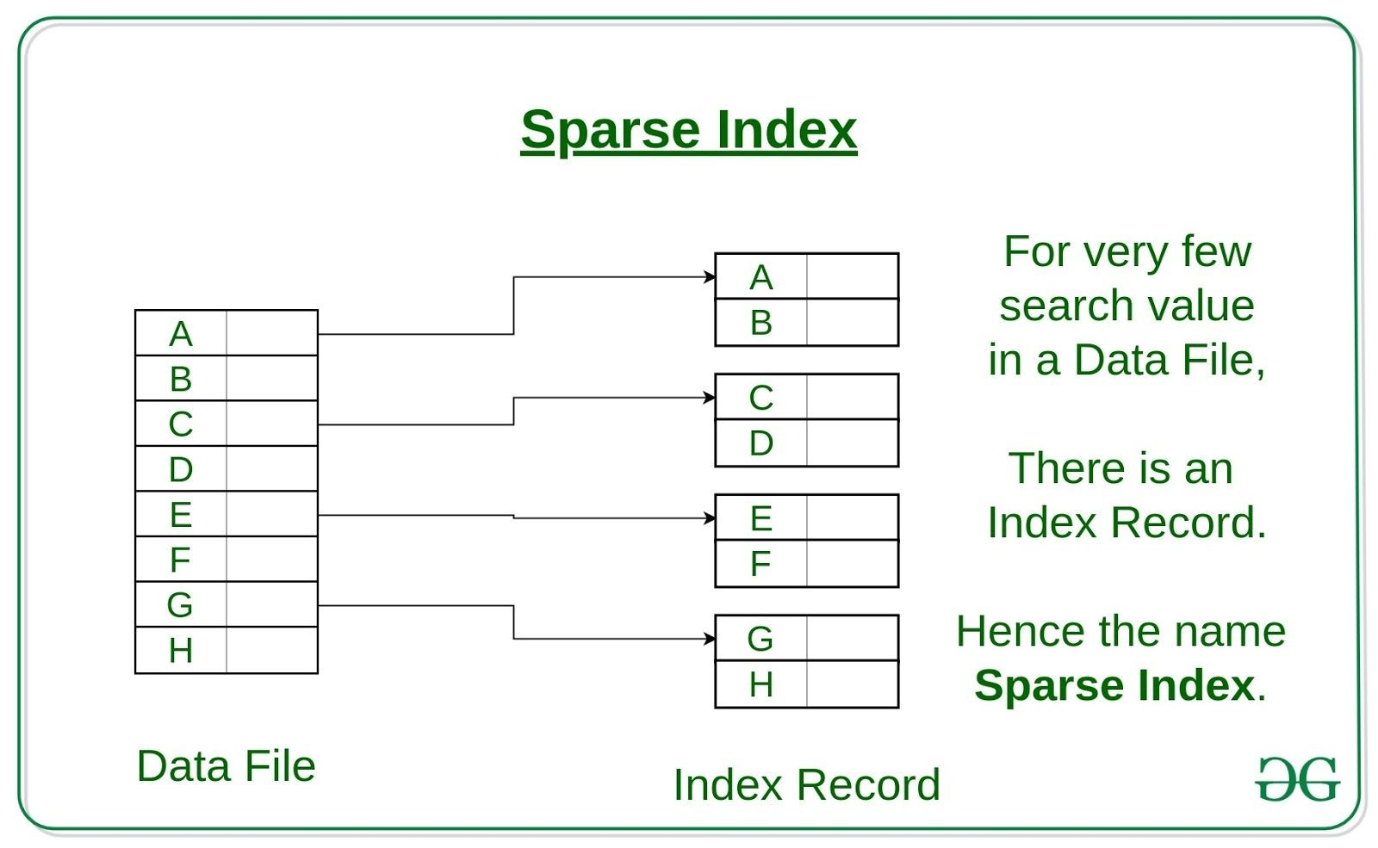

## Clustered Indexing

When more than two records are stored in the same file these types of storing known as cluster indexing. By using the cluster indexing we can

reduce the cost of searching reason being multiple records related to the same thing are stored at one place and it also gives the frequent join of more than two tables(records).

Clustering index is defined on an ordered data file. The data file is ordered on a non-key field. In some cases, the index is created on non-primary key columns which may not be unique for each record. In such cases, in order to identify the records faster, we will group two or more columns together to get the unique values and create index out of them. This method is known as the clustering index. Basically, records with similar characteristics are grouped together and indexes are created for these groups.

For example, students studying in each semester are grouped together. i.e. 1st​ Semester students, 2​ nd​ semester students, 3​ rd​ semester students etc are​ grouped.

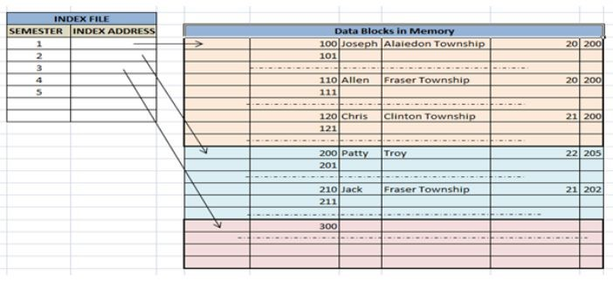

Clustered index sorted according to first name (Search key)

**Secondary Index or Non-clustered index:**

In the sparse indexing, as the size of the table grows, the size of mapping also grows. These mappings are usually kept in the primary memory so that address fetch should be faster. Then the secondary memory searches the actual data based on the address got from mapping. If the mapping size grows then fetching the address itself becomes slower. In this case, the sparse index will not be efficient. To overcome this problem, secondary indexing is introduced.

A non clustered index just tells us where the data lies, i.e. it gives us a list of virtual pointers or references to the location where the data is actually stored. Data is not physically stored in the order of the index. Instead, data is present in leaf nodes. For eg. the contents page of a book. Each entry gives us the page number or location of the information stored. The actual data here(information on each page of the book) is not organized but we have an ordered reference(contents page) to where the data points actually lie. We can have only dense ordering in the non-clustered index as sparse ordering is not possible because data is not physically organized accordingly.

It requires more time as compared to the clustered index because some amount of extra work is done in order to extract the data by further following the pointer. In the case of a clustered index, data is directly present in front of the index.

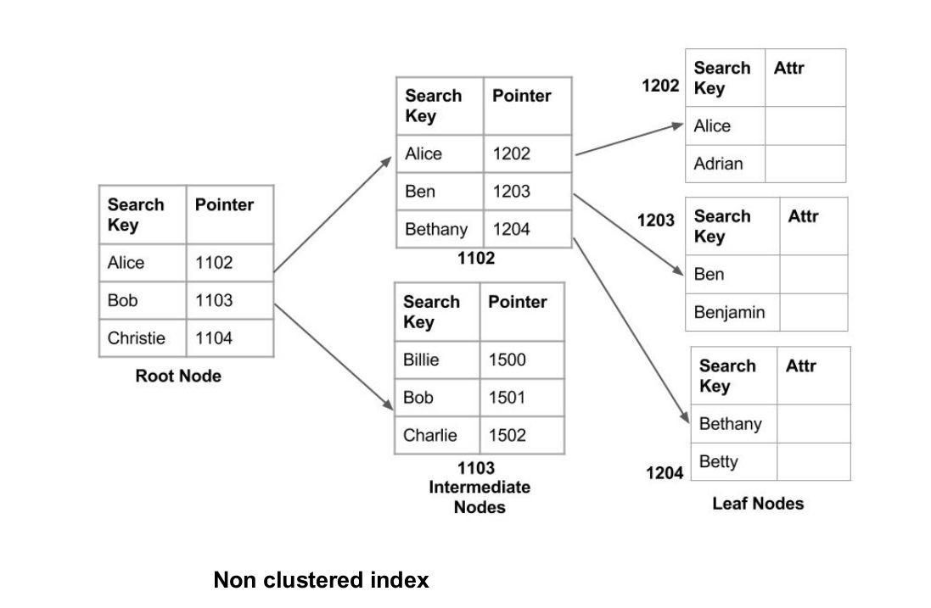

# Introduction of B-Tree

**Introduction:**

B-Tree is a self-balancing search tree. In most of the other self-balancing search trees (like AVL and Red-Black Trees), it is assumed that everything is in main memory. To understand the use of B-Trees, we must think of the huge amount of data that cannot fit in main memory. When the number of keys is high, the data is read from disk in the form of blocks. Disk access time is very high compared to the main memory access time. The main idea of using

B-Trees is to reduce the number of disk accesses. Most of the tree operations (search, insert, delete, max, min, ..etc ) require O(h) disk accesses where h is the height of the tree. B-tree is a fat tree. The height of B-Trees is kept low by putting maximum possible keys in a B-Tree node. Generally, the B-Tree node size is kept equal to the disk block size. Since the height of the B-tree is low so total disk accesses for most of the operations are reduced significantly compared to balanced Binary Search Trees like AVL Tree, Red-Black Tree,

..etc.

**Time Complexity of B-Tree:**

Sr. No. Algorithm Time Complexity

1. Search O(log n)
2. Insert O(log n)
3. Delete O(log n)

**“n” is the total number of elements in the B-tree.**

**Properties of B-Tree:**

* 1. All leaves are at the same level.
  2. A B-Tree is defined by the term *minimum degree*​ ​ ‘t’. The value of t

depends upon disk block size.

* 1. Every node except root must contain at least (ceiling)([t-1]/2) keys.

The root may contain minimum 1 key.

* 1. All nodes (including root) may contain at most t – 1 keys.
  2. Number of children of a node is equal to the number of keys in it plus

1.

* 1. All keys of a node are sorted in increasing order. The child between two keys k1 and k2 contains all keys in the range from k1 and k2. 7. B-Tree grows and shrinks from the root which is unlike Binary Search Tree. Binary Search Trees grow downward and also shrink

from downward.

8. Like other balanced Binary Search Trees, time complexity to search,

insert and delete is O(log n).

Following is an example of B-Tree of minimum order 5. Note that in practical B-Trees, the value of the minimum order is much more than 5.

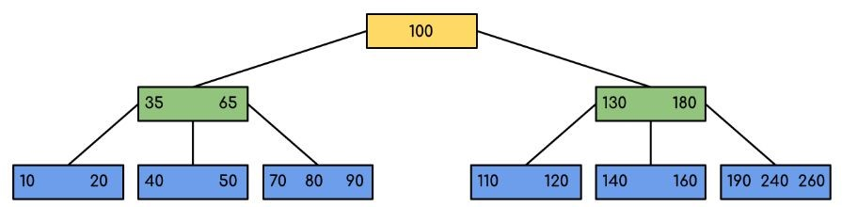

We can see in the above diagram that all the leaf nodes are at the same level and all non-leaf have no empty sub-tree and have keys one less than the number of their children.

**Interesting Facts:**

The minimum height of the B-Tree that can exist with n number of nodes and m is the maximum number of children of a node can have is:



2. The maximum height of the B-Tree that can exist with n number of nodes and d is the minimum number of children that a non-root node can have

is:



and



**Traversal in B-Tree:**

Traversal is also similar to Inorder traversal of Binary Tree. We start from the leftmost child, recursively print the leftmost child, then repeat the same process for remaining children and keys. In the end, recursively print the rightmost child.

**Search Operation in B-Tree:**

Search is similar to the search in Binary Search Tree. Let the key to be searched be k. We start from the root and recursively traverse down. For every visited non-leaf node, if the node has the key, we simply return the node. Otherwise, we recur down to the appropriate child (The child which is just before the first greater key) of the node. If we reach a leaf node and don’t find k in the leaf node, we return NULL.

**Logic:**

Searching a B-Tree is similar to searching a binary tree. The algorithm is similar and goes with recursion. At each level, the search is optimised as if the key value is not present in the range of parent then the key is present in another branch. As these values limit the search they are also known as limiting value or separation value. If we reach a leaf node and don’t find the desired key then it will display NULL.

**Example: Searching 120 in the given B-Tree.**



**Solution:**

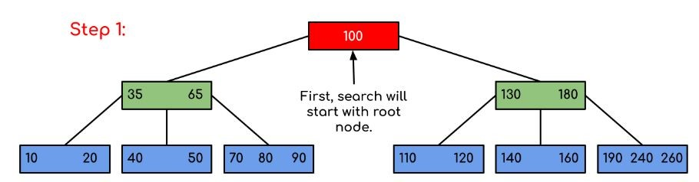

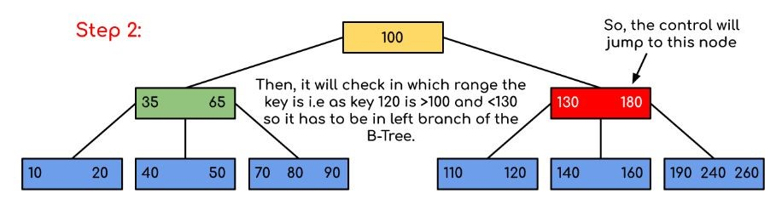

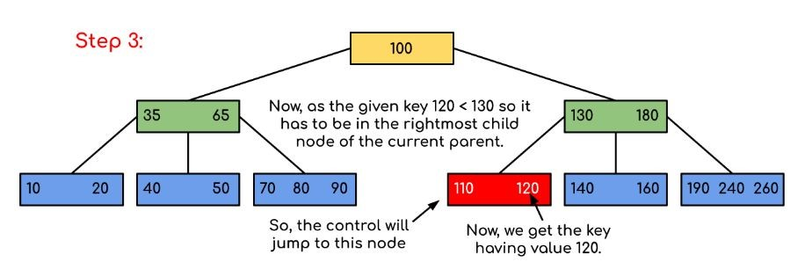

In this example, we can see that our search was reduced by just limiting the chances where the key containing the value could be present. Similarly if within the above example we’ve to look for 180, then the control will stop at step 2 because the program will find that the key 180 is present within the current node. And similarly, if it’s to seek out 90 then as 90 < 100 so it’ll go to the right subtree automatically and therefore the control flow will go similarly as shown within the above example.

## Insert Operation in B-Tree

Let us understand the algorithm with an example tree of minimum degree ‘t’ as 3 and a sequence of integers 10, 20, 30, 40, 50, 60, 70, 80 and 90 in an initially empty B-Tree.

Initially root is NULL. Let us first insert 10.

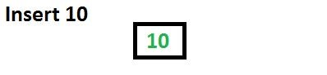

Let us now insert 20, 30, 40 and 50. They all will be inserted in root because the maximum number of keys a node can accommodate is 2*t – 1 which is 5.

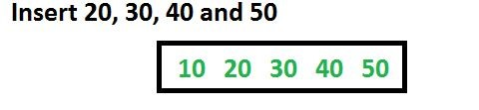

Let us now insert 60. Since the root node is full, it will first split into two, then 60 will be inserted into the appropriate child.

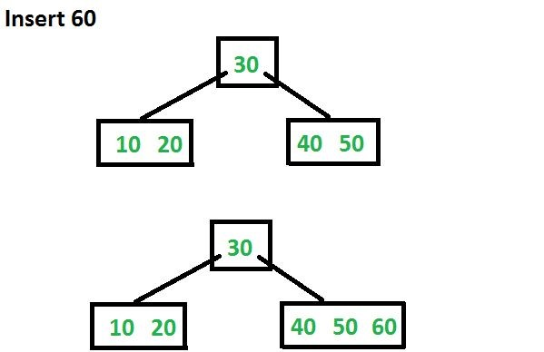

Let us now insert 70 and 80. These new keys will be inserted into the appropriate leaf without any split.

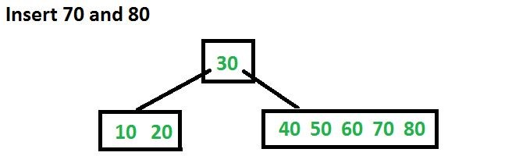

Let us now insert 90. This insertion will cause a split. The middle key will go up to the parent.

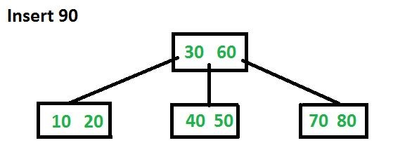

## Delete Operation in B-Tree

The following figures explain the deletion process.

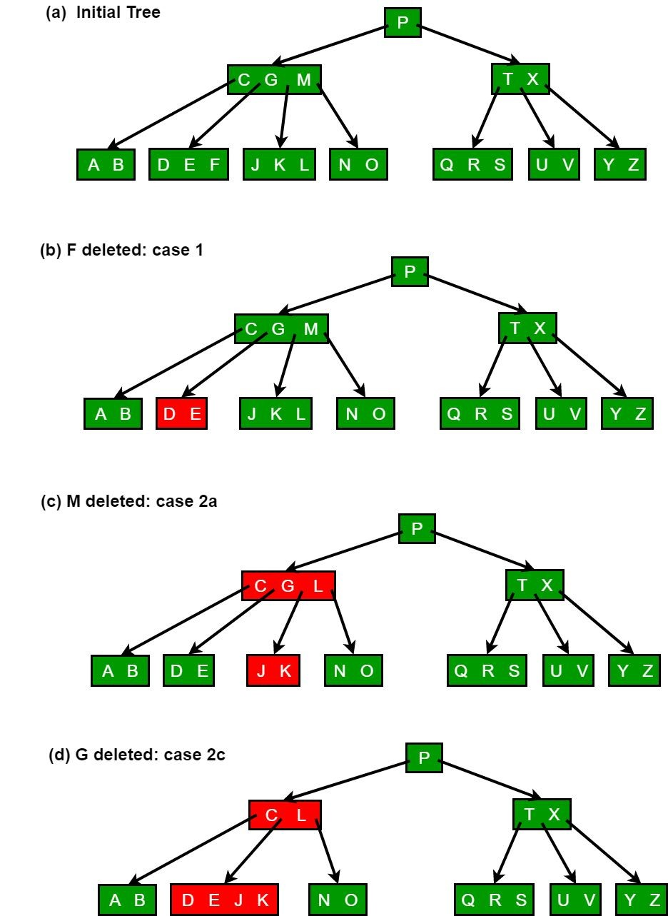

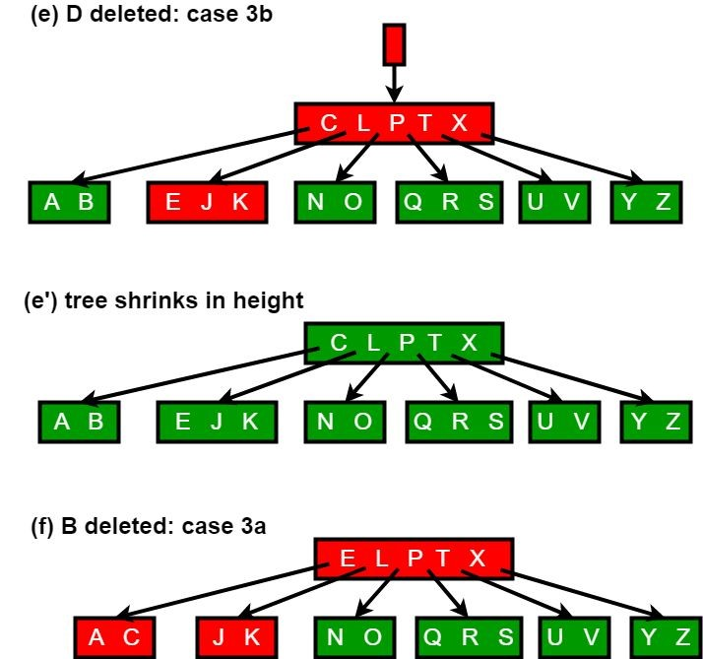

# Hashing

In a huge database structure, it is very inefficient to search all the index values and reach the desired data. Hashing technique is used to calculate the direct location of a data record on the disk without using index structure.

In this technique, data is stored at the data blocks whose address is generated by using the hashing function. The memory location where these records are stored is known as a data bucket or data blocks.

In this, a hash function can choose any of the column values to generate the address. Most of the time, the hash function uses the primary key to generate the address of the data block. A hash function is a simple mathematical function to any complex mathematical function. We can even consider the primary key itself as the address of the data block. That means each row whose address will be the same as a primary key stored in the data block.

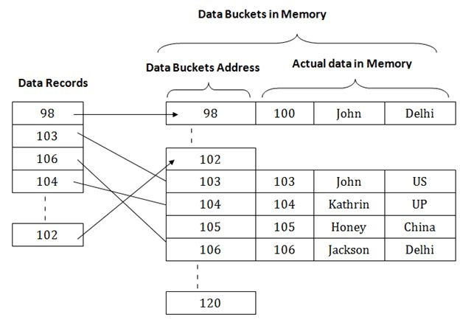

The above diagram shows the data block addresses the same as the primary key value. This hash function can also be a simple mathematical function like exponential, mod, cos, sin, etc. Suppose we have a mod (5) hash function to determine the address of the data block. In this case, it applies mod (5) hash function on the primary keys and generates 3, 3, 1, 4 and 2 respectively, and records are stored in those data block addresses.

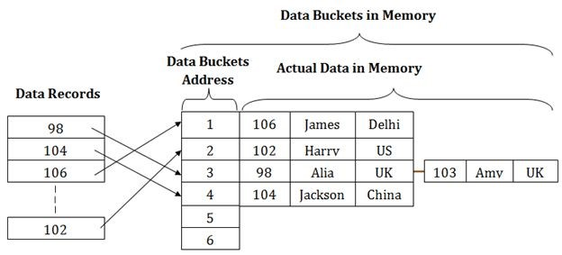

**Types of Hashing:**

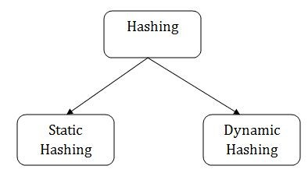

* Static Hashing
* Dynamic Hashing

# Static Hashing

In static hashing, the resultant data bucket address will always be the same. That means if we generate an address for EMP_ID =103 using the hash function mod (5) then it will always result in the same bucket address 3. Here, there will be no change in the bucket address.

Hence in this static hashing, the number of data buckets in memory remains constant throughout. In this example, we will have five data buckets in the memory used to store the data.

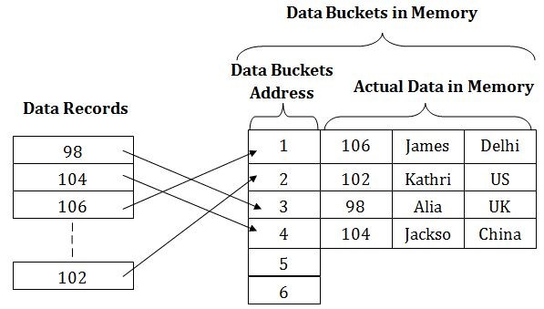

## Operations of Static Hashing

* **Searching a record**

When a record needs to be searched, then the same hash function retrieves the address of the bucket where the data is stored.

* **Insert a Record**

When a new record is inserted into the table, then we will generate an address for a new record based on the hash key and record is stored in that location.

* **Delete a Record**

To delete a record, we will first fetch the record which is supposed to be deleted.

Then we will delete the records for that address in memory.

* **Update a Record**

To update a record, we will first search it using a hash function, and then the data record is updated.

If we want to insert some new record into the file but the address of a data bucket generated by the hash function is not empty, or data already exists in that address. This situation in the static hashing is known as **bucket overflow**​ . This is a critical​ situation in this method.

To overcome this situation, there are various methods. Some commonly used methods are as follows:

## 1. Open Hashing

When a hash function generates an address at which data is already stored, then the next bucket will be allocated to it. This mechanism is called Linear **Probing**​ .​

**For example:** suppose R3 is a new address which needs to be inserted, the hash​ function generates an address as 112 for R3. But the generated address is already full. So the system searches the next available data bucket, 113 and assigns R3 to

it.

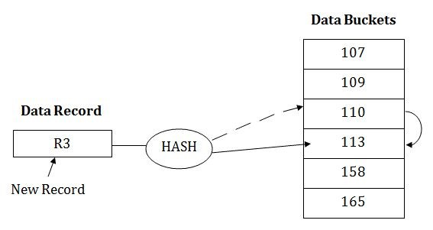

## 2. Close Hashing

When buckets are full, then a new data bucket is allocated for the same hash result and is linked after the previous one. This mechanism is known as ​**Overflow chaining**​.

**For example:**​ Suppose R3 is a new address which needs to be inserted into the table, the hash function generates an address as 110 for it. But this bucket is full to store the new data. In this case, a new bucket is inserted at the end of 110 buckets and is linked to it.

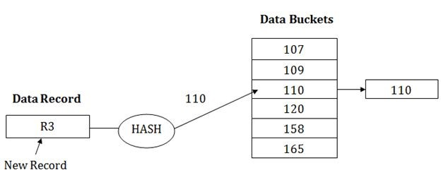

# Dynamic Hashing

* The dynamic hashing method is used to overcome the problems of static hashing like bucket overflow.
* In this method, data buckets grow or shrink as the records increases or decreases. This method is also known as Extendable hashing method.
* This method makes hashing dynamic, i.e., it allows insertion or deletion without resulting in poor performance.

## How to search a key

* First, calculate the hash address of the key.
* Check how many bits are used in the directory, and these bits are called as i.
* Take the least significant i bits of the hash address. This gives an index of the directory.
* Now using the index, go to the directory and find the bucket address where the record might be.

## How to insert a new record

* Firstly, you have to follow the same procedure for retrieval, ending up in some bucket.
* If there is still space in that bucket, then place the record in it.
* If the bucket is full, then we will split the bucket and redistribute the records.

**For example:**

Consider the following grouping of keys into buckets, depending on the prefix of their hash address:

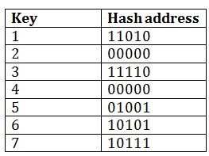

The last two bits of 2 and 4 are 00. So it will go into bucket B0. The last two bits of 5 and 6 are 01, so it will go into bucket B1. The last two bits of 1 and 3 are 10, so it will go into bucket B2. The last two bits of 7 are 11, so it will go into B3.

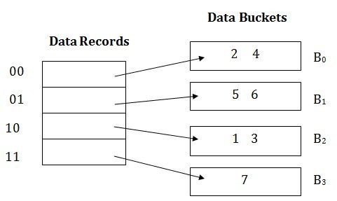

**Insert key 9 with hash address 10001 into the above structure:**

* Since key 9 has a hash address 10001, it must go into the first bucket. But bucket B1 is full, so it will get split.
* The splitting will separate 5, 9 from 6 since the last three bits of 5, 9 are 001, so it will go into bucket B1, and the last three bits of 6 are 101, so it will go into bucket B5.
* Keys 2 and 4 are still in B0. The record in B0 pointed by the 000 and 100 entry because last two bits of both the entry are 00.
* Keys 1 and 3 are still in B2. The record in B2 pointed by the 010 and 110 entry because last two bits of both the entry are 10.
* Key 7 are still in B3. The record in B3 pointed by the 111 and 011 entry because last two bits of both the entry are 11.

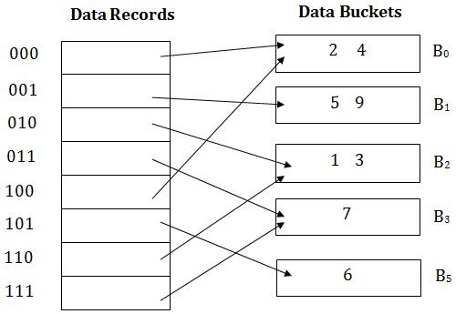

## Advantages of dynamic hashing

* In this method, the performance does not decrease as the data grows in the system. It simply increases the size of memory to accommodate the data.
* In this method, memory is well utilized as it grows and shrinks with the data. There will not be any unused memory lying.
* This method is good for the dynamic database where data grows and shrinks frequently.

## Disadvantages of dynamic hashing

* In this method, if the data size increases then the bucket size is also increased. These addresses of data will be maintained in the bucket address table. This is because the data address will keep changing as buckets grow and shrink. If there is a huge increase in data, maintaining the bucket address table becomes tedious.
* In this case, the bucket overflow situation will also occur. But it might take little time to reach this situation than static hashing.

**UNIT - 3 COMPLETED**